**EXERCISES FOR WINDOWS FORM**

**Exercise 1: Create a Windows Form application in C# to calculate the sum of two numbers**

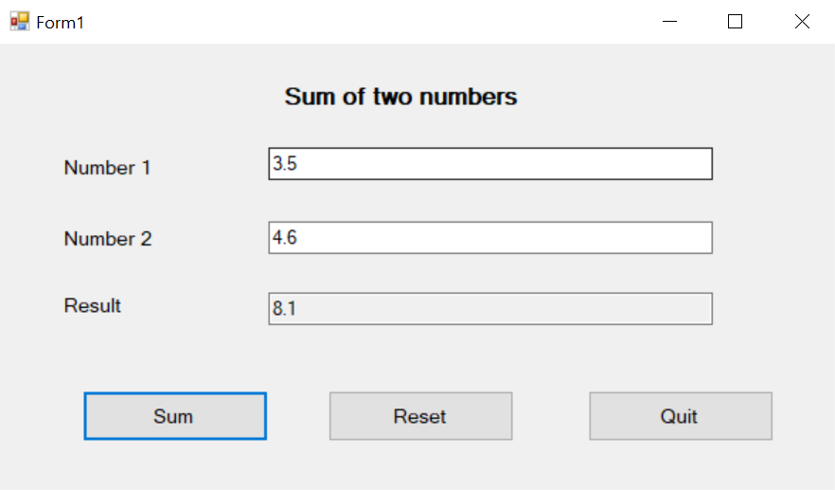

**using System;**

**using System.Collections.Generic;**

**using System.ComponentModel;**

**using System.Data;**

**using System.Drawing;**

**using System.Linq;**

**using System.Text;**

**using System.Threading.Tasks;**

**using System.Windows.Forms;**

**namespace Add2Numbers**

**{**

**public partial class Form1 : Form**

**{**

**public Form1()**

**{**

**InitializeComponent();**

**txtNumber1.Select();**

**txtResult.ReadOnly = true;**

**}**

**private void btnSum_Click(object sender, EventArgs e)**

**{**

**double sum = 0;**

**try**

**{**

**sum = double.Parse(txtNumber1.Text) + double.Parse(txtNumber2.Text);**

**}**

**catch (Exception ex)**

**{**

**MessageBox.Show($"Please enter a number \n {ex.Message}");**

**}**

**txtResult.Text = sum.ToString();**

**}**

**private void btnQuit_Click(object sender, EventArgs e)**

**{**

**this.Close();**

**}**

**private void btnReset_Click(object sender, EventArgs e)**

**{**

**txtNumber1.Text = "";**

**txtNumber2.Text = "";**

**txtResult.Text = "";**

**}**

**}**

**}**

**Exercise 2:**

**Accessing website:** [**http://csharp.net-informations.com/**](http://csharp.net-informations.com/)

**to practice exercises about windows form**

**C# Graphical User Interface Tutorial**

1. [How to Create a C# Windows Forms Application](http://csharp.net-informations.com/gui/cs_forms.htm)
2. [C# Label Control](http://csharp.net-informations.com/gui/label.htm)
3. [C# Button Control](http://csharp.net-informations.com/gui/button.htm)
4. [C# TextBox Control](http://csharp.net-informations.com/gui/cs-textbox.htm)
5. [C# ComboBox](http://csharp.net-informations.com/gui/cs-combobox.htm)
6. [C# ListBox Control](http://csharp.net-informations.com/gui/cs-listbox.htm)
7. [C# Checked ListBox Control](http://csharp.net-informations.com/gui/cs-checkedlistbox.htm)
8. [C# RadioButton Control](http://csharp.net-informations.com/gui/cs-radiobutton.htm)
9. [C# CheckBox Control](http://csharp.net-informations.com/gui/cs-checkbox.htm)
10. [C# PictureBox Control](http://csharp.net-informations.com/gui/cs-picturebox.htm)
11. [C# ProgressBar Control](http://csharp.net-informations.com/gui/cs-progressbar.htm)
12. [C# ScrollBars Control](http://csharp.net-informations.com/gui/cs-scrollbars.htm)
13. [C# DateTimePicker Control](http://csharp.net-informations.com/gui/cs-datetimepicker.htm)
14. [C# Treeview Control](http://csharp.net-informations.com/gui/cs-treeview.htm)
15. [C# ListView Control](http://csharp.net-informations.com/gui/cs-listview.htm)
16. [C# Menu Control](http://csharp.net-informations.com/gui/cs-menu.htm)
17. [C# MDI Form](http://csharp.net-informations.com/gui/cs-mdi-form.htm)
18. [C# Color Dialog Box](http://csharp.net-informations.com/gui/cs-color-dialog-box.htm)
19. [C# Font Dialog Box](http://csharp.net-informations.com/gui/cs-font-dialog-box.htm)
20. [C# OpenFile Dialog Box](http://csharp.net-informations.com/gui/cs-openfile-dialog-box.htm)
21. [C# Print Dialog Box](http://csharp.net-informations.com/gui/cs-print-dialog-box.htm)
22. [KeyPress event in C# , KeyDown event in C# , KeyUp event in C#](http://csharp.net-informations.com/gui/key-press-cs.htm)
23. [How to create Dynamic Controls in C#?](http://csharp.net-informations.com/gui/dynamic-controls-cs.htm)
24. [Keep Form on Top of All Other Windows](http://csharp.net-informations.com/gui/form-on-top-cs.htm)
25. [C# Timer Control](http://csharp.net-informations.com/gui/timer-cs.htm)